Fix position of nav bar #3488

**Points explained in this documentation**

**1. What is Navigation Bar**

**2. What does Fix position Of Nav-Bar means**

**3. Why to fix position**

**4. How to fix position and code explanation**

**5. Example of Implementation**

**6. Code**

Navigation Bar is a section of a graphical user interface intended to aid visitors in accessing information.

They are implemented in file browsers, web browsers and as a design element of some web sites.

These are found at top of websites or apps for making the application user-handy

Fix-Position of nav-bar means when user scrolls the page navigation bar user can still see the nav-bar and access any option.

Since if position will not be fixed then each time user will scroll down and has to access nav-bar he/she has to scroll it upwards, and this will make it really complicated.

This problem can be fixed easily just in three simple codes. Let us look into it

1. Set the navbar to fixed position

**position: fixed;**

1. Position the navbar at the top of the page

**top: 0;**

1. Full width    
   **width: 100%;**

Explanation of all three codes

 First line of code is position:fixed; this is written to make postion fixed , second code describes where the position should be fixed like here nav-bar needs its position to be fixed at top, for footer it can be bottom, similarly width is used to set width of nav-bar here this can also be reduced and increased accordingly by developer.Below is a example of Implementation of above explained code.

**EXAMPLE**

**BEFORE**

As we can see here there is no navigation bar so let us add code in header of this to make nav-bar visible all the time.



**AFTER**

After implementation we can see nav-bar is easily visible. Yey, mission accomplished!

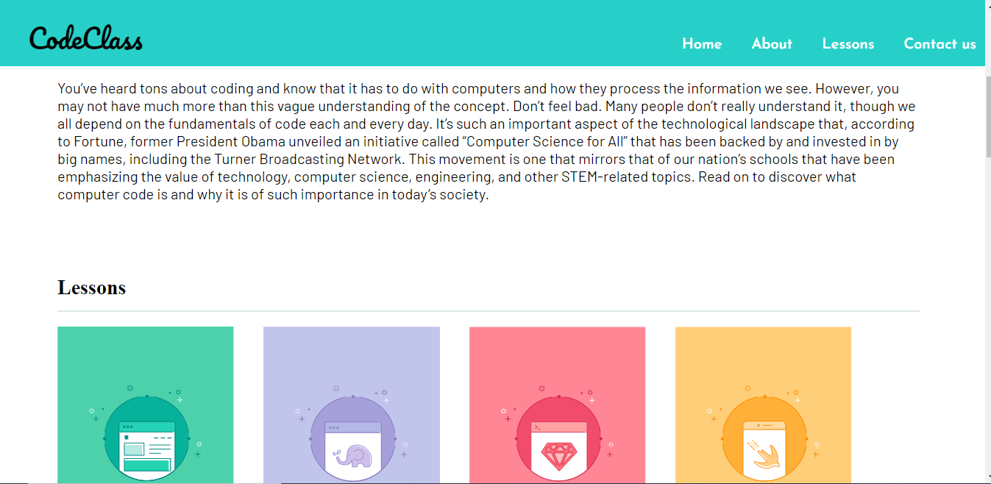

CODE

If nav-bar is named under class=header

.header {  
  position: fixed;   
  top: 0;   
  width: 100%;  
}